**Run NIINs report**

First, run a report listing the NIINs you want included in your FEDLOG report; (use URSA or NSN data)

The NIINs report should just be a list of all the target NIINs, put in the 9-digit NIIN format, and in a “text” file as a number; (example: NIIN 000013733 would be listed for NSN 5120000013733); Note: you have to list all 9 digits even if leading zeros etc.

Save the NIINs file in the location of your choice.

**\*\*\*\*\*\*\*\*\*\*\*\*\*\*\*\*\*\*\*\*\*\*\*\*\*\*\*\*\*\*\*\*\*\*\*\*\*\*\*\*\*\*\*\*\*\*\*\*\*\*\*\*\*\*\*\*\*\***

**Running a report in FEDLOG;**

**[Must first download FEDLOG, See separate guide for this]**

1. Open Fedlog

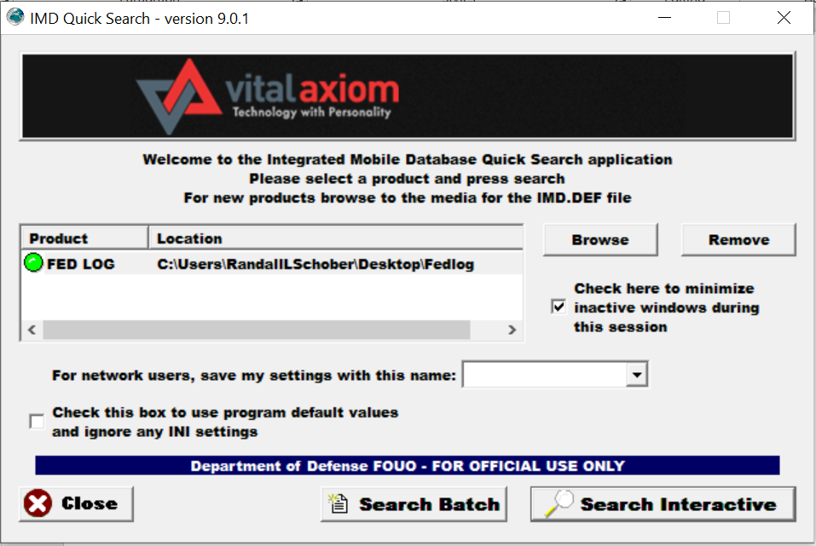

1. Select “Search Batch”

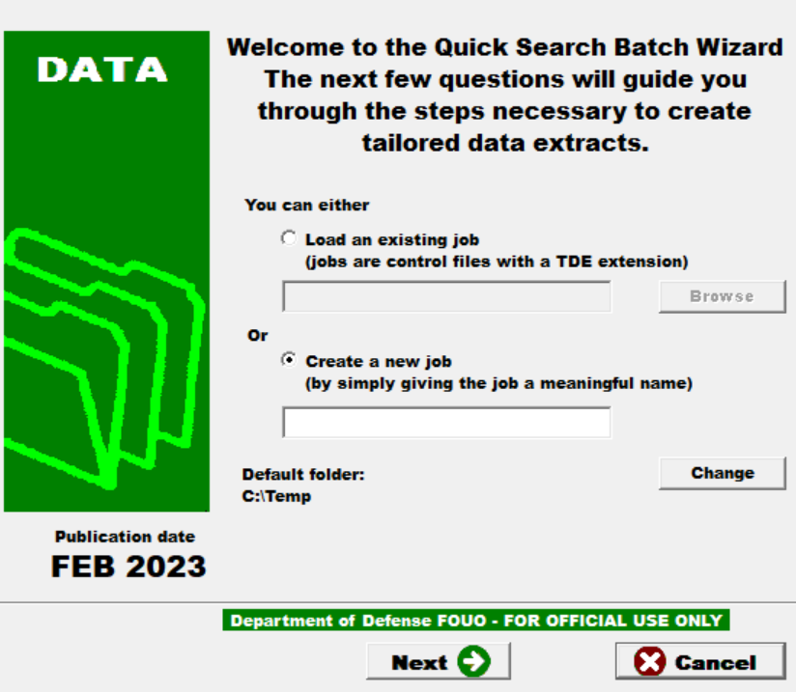

1. Select “create a new job” and name this report that you are creating – and putting the report you are creating at the place of your choice, in my case “c:\temp”.

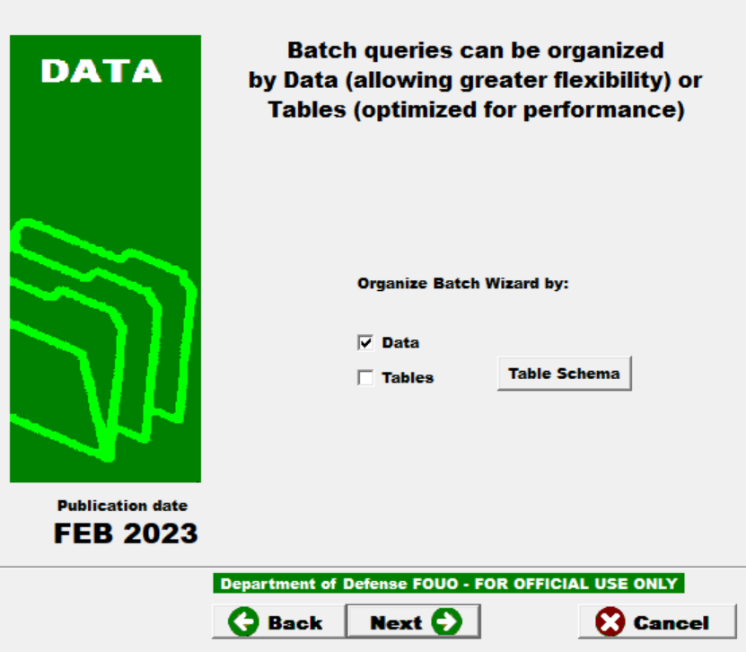

1. Select “data”
2. Select “next”

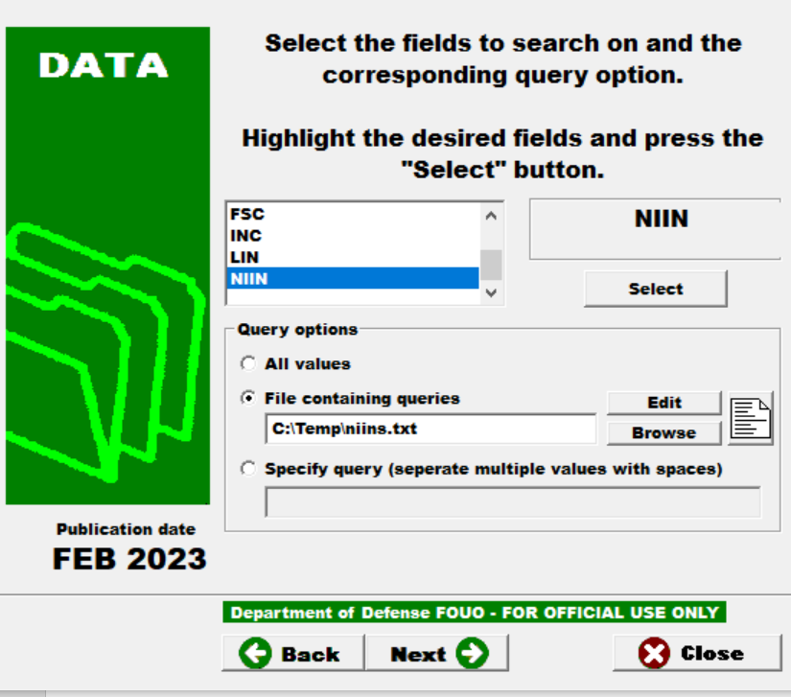

6: On the fields to search on – select “NIIN” and then identify the file of target NIINs you created earlier (see above).

7. Select “next”

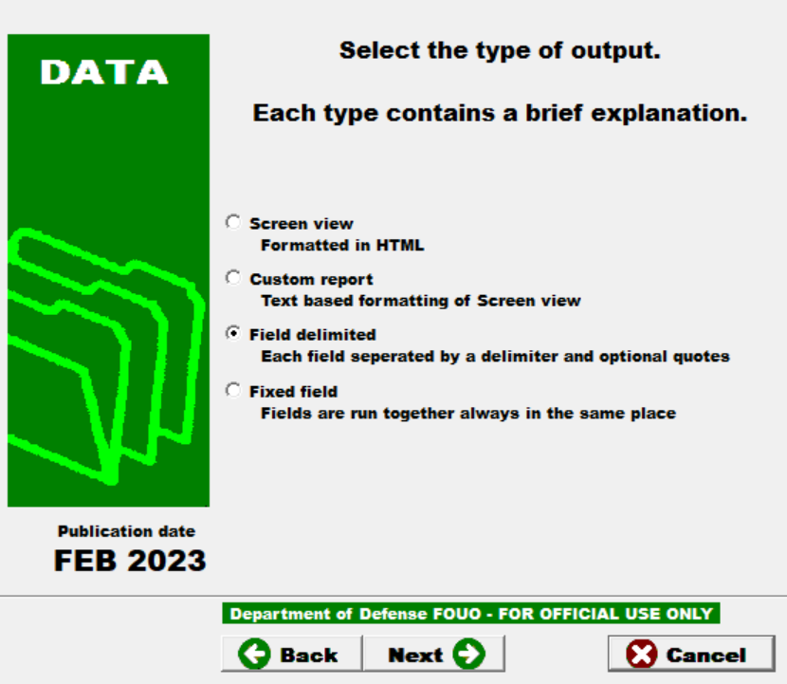

8. Select type of output (I use field delimited)

9. Select “next”

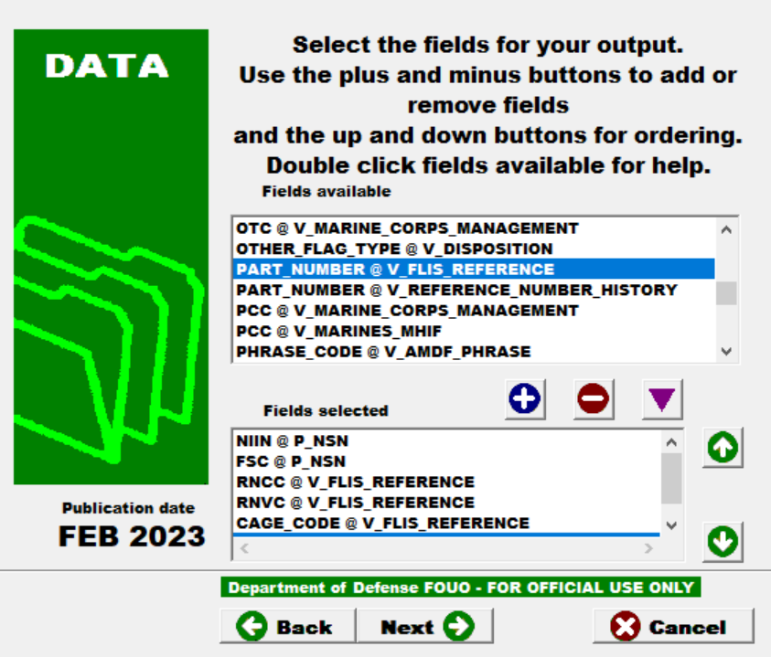

And 

10. select the fields you want for your output. This is where you need to be familiar with the TIR. The @ sign indicates the part of the TIR your report pulls from; For this report, recommend the fields selected above.

11. Select “next”

12. Select “next” again.

Run report

View output. Save output.